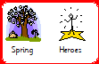
Heroes Planning Spring 2020

 | Week 7 | Week 8 | Week 9 | Week 10 | Week 11 | Week 12
Special dates / events | Shrove Tuesday  St David’s Day |  |  | St Patrick’s Day  1st day of spring  Mother’s Day | Easter | Easter
Monday | Assembly
 | Art – Hand print daffodils & paper leeks – crafts linked to St David’s Day  RE – Buddhist Worship - Flowers | Art - Easter themed - cross  RE – Buddhist Worship - Fruit | Art – Mother’s Day card  RE – The Easter Story | Art – Pot of gold, rainbow twirlers – crafts linked to St Patrick’s Day  RE – The Easter Story | Art – Easter themed - palm leaves & thorny crown  RE – The Easter Story | Art – Easter themed – Easter cards  RE – The Easter Story
Tuesday | Snack – Pancakes  Mark Making – flour & water  Story – The Iron Man | Mark Making – kitchen utensils and paint  Story – The Iron Man | Mark Making – kitchen utensils and paint  Story – The Iron Man | Mark Making – green puffy paint  Story – The Iron Man | Mark Making – twigs and paint  Story – The Iron Man | Mark Making – twigs and paint  Story – The Iron Man
Wednesday | Food play – Welsh cakes  Massage story – Emotions | Food play – Hot cross buns  Massage story - Emotions | Food play – Simnel cake  Massage story - Emotions | Food play – Soda bread  Massage story – Spring | Food play – Chocolate nests  Massage story - Spring | Food play – Easter biscuits  Massage story - Spring
Thursday | Dance Interaction –  Dance Through the Ages  Spring Yoga | Dance Interaction –  Dance Through the Ages  Spring Yoga | Dance Interaction –  Dance Through the Ages  Spring Yoga | Dance Interaction – Dance Through the Ages  Spring Yoga | Dance Interaction – Dance Through the Ages  Spring Yoga | Dance Interaction – Dance Through the Ages  Spring Yoga
Friday | Enterprise – Activities relating to developing the outdoor patio area into a sensory garden. Class jobs – recycling, tidying  Body Awareness – Here We Go!  Assembly
Art
Start all lessons with the object of reference and the symbol and sign ‘Art’
Hand and arm warm up exercises – where are my hands and arms? Squeezes, whole arm movement, rub hands together, move fingers, shake hands, move wrists (jazz hands)
Finish all lessons with a celebration of the work achieved
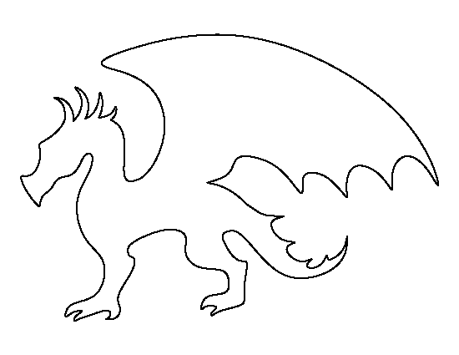
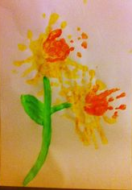
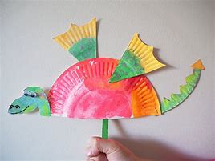
Week 7 – St David’s Day crafts – handprint daffodils dragon crafts
Resources: story of St David (https://www.youtube.com/watch?v=BQbeWFxsRp0) , yellow, red
orange, green paint, paper plates, symbols to
reinforce key vocab
Week 8 – Easter themed – Cross. Mask off a cross shape on black card and use orange and yellow paint. When the paint is dry remove the masking tape to reveal a silhouette of the cross (The cross symbolises Jesus’ victory over death – he rose from the dead)
Resources: Easter Story, yellow, orange paint, black card, masking tape, symbols to reinforce key vocab

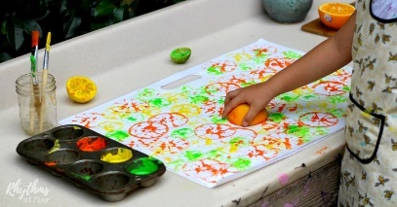
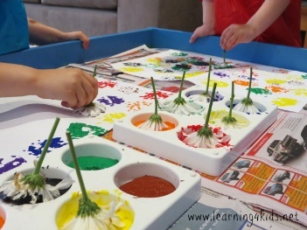
Week 9 – Mother’s Day Card, print flower shapes using flowers and citrus fruit, cut
out once dry into flower shapes ready for pupils to put onto a card
Resources: Why and how do we celebrate Mother’s Day, bunch of
flowers, citrus fruits, bright coloured paints, white card, symbols to reinforce key
vocab
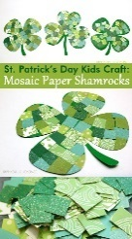
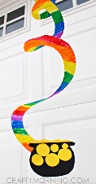
Week 10 – St Patrick’s Day crafts – rainbow pot of gold shamrock mosiac
Resources: Story of St Patrick pot shape on
black card, gold circles for coins, paper plate cut in
spiral, paint in rainbow colours, green paper, shamrock
template on card already cut out, symbols to reinforce
key vocab
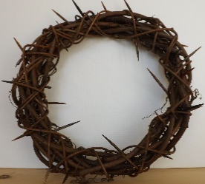
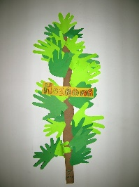
Week 11 – Easter themed - palm leaves. Create a class palm tree with all pupils adding green hand prints (The palm represents when Jesus arrived in Jerusalem)
Thorn crown - glue twigs and sticks onto a circle template (The thorns represent sin, sorrow and hardship)
Resources: Easter Story, green paint, light coloured sugar paper, word ‘Hosanna’, sticks and
twigs, glue, circle template with centre cut out, symbols to reinforce key vocab

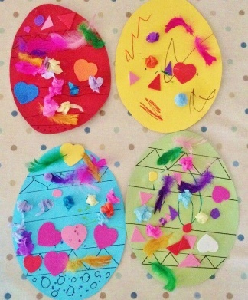
Week 12 – Easter themed – easter cards. Collage egg shapes with different materials (pupils to make choices of materials to use) Once collaged make into a card.
Resources: Easter Story, Easter egg shapes on bright card, different materials to collage the eggs.

The Easter Story

Resources Lesson to take place in the classroom, PowerPoint with supporting music, light the classroom in orange

Pupils to be introduced to the session using Enigma – Sadness. Once settled move music on to Jerusalem – De Pacem Domini (put this track on repeat and have playing quietly in the background)
Jesus travelled to Jerusalem on a donkey Jesus on a donkey (repeat over and over)
Support using wooden blocks to make clip clop sounds and fur for the donkey. All pupils to be encouraged to reach out, follow, hold and manipulate the stimuli. Start and stop and wait for pupil indication that they would like more. Claire to judge when it is appropriate to move the pupils on.
Some people were happy to see Jesus Hosanna!! (repeat over and over)
Support using green fabric and artificial palm leaves. All pupils to be encouraged to reach out, follow, hold and manipulate the stimuli. Start and stop and wait for pupil indication that they would like more. Claire to judge when it is appropriate to move the pupils on.
Not everyone was happy to see Jesus Boo!! (repeat over and over)
Supporting adults to create angry faces using mirrors to support. Look for pupils showing awareness of tone of voice, facial expressions and awareness of own face in the mirror. Start and stop and wait for pupil indication that they would like more. Claire to judge when it is appropriate to move the pupils on.
Jesus had a meal with friends Food and drink (repeat over and over)
Support using bowls of bread and juice in cups / jug. All pupils to be encouraged to reach out, follow, hold and manipulate the stimuli, listen to the pouring of the juice, feel the juice being poured on their hands. Claire to judge when it is appropriate to move the pupils on.
Jesus the teacher Wash your hands (repeat over and over)
Support using damp cloths to wash the pupils hands. All pupils to be encouraged to reach out, follow, hold and manipulate the stimuli. Start and stop and wait for pupil indication that they would like more. Claire to judge when it is appropriate to move the pupils on. Switch the music off
Sssshhhhh time to pray
Take a few moments to sit quietly, allowing the pupils time to use their own voices. Staff will not respond to any vocalisations during this point to encourage the pupils to vocalise between themselves. Claire to judge when it is appropriate to move the pupils on.
Switch the music on Brian Eno – An Ending
Jesus was captured Cross and crown (repeat over and over)
Support using heavy crosses and pressing fingertips around their head as if wearing a thorny crown. All pupils to be encouraged to reach out, follow, hold and manipulate the stimuli. Start and stop and wait for pupil indication that they would like more. Claire to judge when it is appropriate to move the pupils on.
Slowly darken the room down.
Jesus was gone
Support using dark fabric. Pull the fabric over the pupils and encourage them to reach toward it, assisting them to remove it.
Change the music over to Yeha Noha – Sacred Spirit
Once the fabric has been removed from the pupils, slowly brighten the room back up again.
Jesus was alive (repeat over and over) in a surprised voice.
Plenary session to share ‘excellent work’ and share new developments. To celebrate each pupil’s achievements with an applause.

Mark Making
Start all lessons the symbol and sign ‘Mark Making’ (move pupils hands and arms)
Hand and arm warm up exercises – where are my hands and arms? Squeezes, whole arm movement, rub hands together, move fingers, shake hands, move wrists (jazz hands) – warm up to Avicii Levels
Using the Move, Paint, Draw PowerPoint focus on scribble, vertical and horizontal movements.
Finish all lessons with a celebration of the work achieved
Week 7  Pancake day – make marks in dry flour and wet water. Adult to model mark making. | 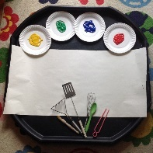  Week 8 & 9  Use kitchen utensils to make marks on paper using paint. Adult to model mark making. | Week 10  St Patrick’s Day – make marks in green puffy paint (3 cups (180g) shaving foam, 1 cup (125g) flour, 1 cup (225ml) glue and green pa paint. Adult to model mark making | Week 11 & 12  Paint on trays/table in lines and blobs and use twigs/sticks to move paint around  Adult to make marks in the paint then clear them away and observe what the child does

Food Play
For each session explore the food and describe using the 5 different senses. Pupils to have opportunities to prepare the ingredients (chopping, rolling, mixing, ripping etc).
Week 6 – Welsh Cakes  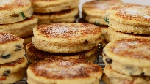  https://www.bbc.co.uk/food/recipes/welshcakes_67264  Ingredients: 110g butter, 225g SR flour, 85g caster sugar, handful sultanas, 1 egg | Week 7 – Hot Cross Buns  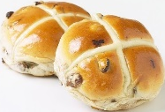  Explore ingredients and taste bought hot cross bun  Ingredients: flour, salt, mixed spice, butter, caster sugar, dried fruit, lemon zest | Week 8 – Simnel Cake  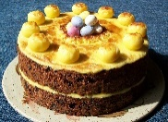  Explore ingredients and taste bought Simnel cake (fruit cake if cannot source Simnel cake)  Ingredients: ground almonds or almond essence, flour, butter, sugar, mixed spice, mixed peel, lemon zest, apricot jam
Week 9 – Soda bread  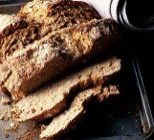  Explore ingredients and taste bought soda bread  Ingredients: flour, wholemeal flour, porridge oats, bicarb soda, salt, butter, buttermilk | Week 10 – Chocolate nests  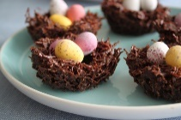  Explore ingredients and make chocolate nests  Ingredients: plain chocolate, treacle, shredded wheat, cornflakes, mini eggs | Week 11 – Easter biscuits  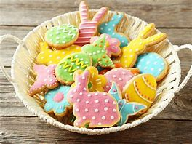  Explore ingredients and decorate pre-made biscuits (Heat oven to 200 degrees, beat 200g butter, add 200g caster sugar and beat with butter, add ½ tsp vanilla essence, slowly mix in 400g plain flour, knead and roll out and cut out the biscuits, bake for 8 – 10 mins)  Ingredients: 200g butter, 200g caster sugar, ½ tsp vanilla essence, 400g plain flour, icing sugar, food colouring

Emotions Massage story - How am I feeling Today?

Why is massage important?
Massage creates a sense of body awareness, it enables pupils to accept positive touch, it calms, it releases tension, it relaxes the mind, muscles and joints, it releases the feel good hormones, it stimulates the sense of smell, it is a good basis for communication, it is great for building relationships and it can help with self-esteem and confidence.
The following massage stories are sourced from ‘Massage Stories – Exploring Communication Through Touch by Andrea Muir with Flo Longhorn’

Reinforce each emotion with the relevant symbol
Start the session with the massage symbol and squeeze down each arm. Colours depict light colours (grey is for white lights).

- The Feelings Song – singalong with pupils squeezing body from top to bottom to cue them in to the session
- Tired – gently massage the scalp and lightly brush hands down from the forehead to the nose
- Content – brush down the sides of the arms from shoulders to wrists, give a secure feeling
- Happy – gently sweep first two fingers of both hands up face from chin up their cheeks to their temples and hold the fingers still on the temples
- Sad – gently sweep first two fingers of both hands down the face from their temples down to their cheeks and to the chin and hold the fingers still on the chin
- Angry – place fist inside the pupil’s palm and wrapping other hand over the top and squeeze fist creating a shudder which they should feel through their palm
- Excited – support pupil to raise both of their hands to face level and shake them lightly in a hand cheering motion
- Scared – quickly and firmly apply light pressure to both shoulders then hold still for a few seconds. Lightly shake their shoulders to simulate shivering
- Surprised – give light squeezes on the body in no order
- Relaxed – shoulder massage
- Calm – lightly stroke from the top of the head down to the nape of the neck, repeat several times
Finish the session celebrating the achievements

Targets (Massage Story)
All pupils:
- To accept appropriate physical touch, to engage / tolerate the interaction, to indicate if they want more / no more of an experience, to anticipate what is coming, to develop an awareness of their self, to initiate interactions, to wait their turn for an available adult if appropriate, to make independent movements of any body part in response to interaction

Spring Massage story

Why is massage important?
Massage creates a sense of body awareness, it enables pupils to accept positive touch, it calms, it releases tension, it relaxes the mind, muscles and joints, it releases the feel good hormones, it stimulates the sense of smell, it is a good basis for communication, it is great for building relationships and it can help with self-esteem and confidence.
The following massage stories are sourced from ‘Massage Stories – Exploring Communication Through Touch by Andrea Muir with Flo Longhorn’

Introduce the session with the massage symbol and squeeze down each arm. Session to start with projection of daffodils and ‘Vivaldi’s Spring from The Four Seasons’
Move the projection on and then it is timed for each slide.

- Lambs, with both hands tap the arms and legs as if lambs are frolicking in the fields. Move in all different directions.
- Rabbit, with a lightly clenched hand, tap one area on the pupil several times as if a rabbit were tapping its hind legs. Move to a different area and repeat several times.
- Caterpillar use forefinger and middle finger together and gently run them from the pupils fingers, over their wrists, up their arms and over their shoulders. Move slowly with a slight pulsing action from side to side as if the caterpillar is searching.
- Cocoon, hold the pupils arm just below the elbow and hold still for a few moments. Run your hand using a firm pressure up to the wrist and then lighten the pressure and encourage the pupil to splay their fingers like a butterfly emerging
- Butterfly, place hands lightly on shoulders and move across towards the neck and up the neck to just under the ears and then trace the movement back to the shoulders.
- Mowing the Grass, move your hand/fingers in a straight line up and down the leg from the ankle to the knee.
- Leaves, hold pupil’s hand in a fist and then slowly support them to uncurl their fingers one by one, like a new spring leaf
- Planting bulbs, place your thumb in the pupils cupped hand and gently wiggle thumb as if making a hole in the earth, add some seeds using fingertips and then use the side of your hand to scoop the earth back in and pat it down.
- Daffodils / Spring Flowers, individually massage each finger from base to tip and give a little wiggle at the end to represent the end of the long stem.
- April Showers, gently patter with fingers from the top of their head all the way down to their feet.
End with ‘Weather Storm’ by Craig Armstrong, finish the session celebrating the achievements
Targets (Massage Story)
All pupils:
- To accept appropriate physical touch, to engage / tolerate the interaction, to indicate if they want more / no more of an experience, to anticipate what is coming, to develop an awareness of their self, to initiate interactions, to wait their turn for an available adult if appropriate, to make independent movements of any body part in response to interaction

Dance Interaction
Why is dance interaction important?
Dance Interaction is teacher led with created opportunities for pupils to initiate a response. The focus of the session is to use movement to music to develop communication skills. Pupils are also encouraged to move their bodies independently

Warm up – Squeezes and deep pressures down the body

Dances Through the Ages

Assist pupils to move arms and legs to move along to the music

Cool Down: Use slow movements down the arms and legs to cool them down
Complete lesson recording whilst pupils listen to the music
Targets
All pupils:
- To accept appropriate physical touch
- To engage / tolerate the interaction
- To indicate if they want more / no more of an experience
- To anticipate what is coming
- To develop an awareness of their self
- To initiate interactions
- To wait their turn for an available adult if appropriate
- To make independent movements of any body part in response to interaction

Spring Yoga
Why is yoga important?
Many children with autism may have sensitivities to lights, noise, smells, texture and taste causing them to become agitated. Yoga can help to decrease the amount of sensory stimulation they are experiencing by decreasing their anxiety, releasing energy and calming down their sensory system.

Preparation – pupils to be positioned on mats where appropriate.

Have relaxing music playing in the background

Warm up – Squeezes and deep pressures down the body

Yoga moves:
1. The sun – reach up in the air and place palms together
2. Tree - if possible, bend one leg up, otherwise sway from side to side like a tree in the breeze
3. Bird – flap arms like a bird
4. Rain – let arms flop like falling rain
5. Planting a garden – move legs up as if bending down to plant seeds
6. Bee – move arms quite quickly like a bee and make a humming sound
7. Butterfly – move legs from centre out to the side like a butterfly flapping its wings
8. Relaxing in the park – breath and rest

Assist pupils to move arms and legs to move along to the music

Cool Down: Use slow movements down the arms and legs to cool them down
Finish the session with a celebration of achievements
Targets
All pupils:
- To accept appropriate physical touch
- To engage / tolerate the interaction
- To indicate if they want more / no more of an experience
- To anticipate what is coming
- To develop an awareness of their self
- To initiate interactions
- To wait their turn for an available adult if appropriate
- To make independent movements of any body part in response to interaction

Body Awareness – Here we Go!

Start session with object of reference (doll) and the symbol.

Follow the PowerPoint ‘Here We Go’ vocal led music

The music leads us through exploring arms, legs, hands, fingers, tummy, knees, feet, head, ears, mouth and nose.

It helps the pupils to develop their self- awareness, counting, respect for others, imitation, anticipation and names of their body parts.

Targets
- To accept appropriate physical touch
- To engage / tolerate the interaction
- To indicate if they want more / no more of an experience
- To anticipate what is coming
- To develop an awareness of their self
- To initiate interactions
- To wait their turn for an available adult if appropriate
- To make independent movements of any body part in response to interaction

- AB, MJN & JC to attempt to identify parts of their bodies relating to the session

My Communication
Question | Teacher’s Notes | Pupil Activity/Objectives
How can I develop my communication and build relationships? | Intensive Interaction approach is used to develop the fundamentals of communication. It works on early interaction abilities – how to enjoy being with other people – to relate, interact, know, understand and practice communication routines.  It teaches and develops attainments such as use and understanding of eye contacts, facial expressions, vocalisations leading to speech, taking turns in exchanges of conversations and the structure of conversation.  Source: https://www.intensiveinteraction.org/ | - Intensive Interaction is pupil led with no objectives! When talking with friends we don’t have a list of targets / objectives to work to, we enjoy the conversation
How can I build the pathways in my brain? | HANDLE (Holistic Approach to Neurological development and Learning Efficiency) is a set of activities which help the brain to develop building neural pathways. http://www.handle.org/  We do the following activities daily in class:  Hug and Tug start with dominant hand and gently tug each finger saying ‘Hug & Tug’, work along each finger on both hands.  Why? This helps both sides of the brain to work together - It promotes the differentiation of fingers and makes pupils aware of ‘my’ hands - It strengthens the finger muscle tone - It stimulates the reflexology points for the sinuses, jaw and mouth  Buzz Snap – Start with dominant hand and shake each finger from knuckle to the nail and at the nail give a little pinch and pull your hand off.  Why? It gives pupils awareness of their fingers and awareness of the movement of their fingers - It helps to desensitise for those with tactile defensiveness - It increases muscle tone and circulation in the fingers  Four part tapping - Start on the pupils dominant side, tap 4 times (slow and firm) on the shoulder on the dominant side, tap 4 times on both shoulders and tap 4 times on shoulder on non-dominant side, tap 4 times (slow and firm) on the thigh on the dominant side, , tap 4 times on both thighs and tap 4 times on the thigh on the non-dominant side. Repeat twice  Why? It helps to regularise the brain patterns, It helps to recognise a rhythmic pattern  Rope Turning - With their dominant hand either place your palm or cup their hand in yours and rotate it 4 times (moving in an inward direction towards the midline), support their other hand and rotate both hands 4 times in the same direction, let go of their dominant hand and keep hold of the non-dominant hand and rotate it 4 times moving in the same direction as previously. Repeat for 1 minute.  Why? It helps both sides of the brain work together - It helps pupils to move body parts without moving others - It helps pupils to make sense of their bodies in space - It helps to recognise a rhythmic pattern  Seated Clapping - Sit in front of pupil and clap your hands together, then reach out with one of your hands (do not go across the midline) and clap with the pupil, clap your hands together again and reach out with your other hand and clap with the pupil. Repeat for 1 minute.  Why? It helps both sides of the brain work together - It helps pupils to move body parts without moving others - It helps to recognise a rhythmic pattern | - To accept appropriate physical touch  - To engage / tolerate the interaction  - To indicate if they want no more of the activity, if they do the activity will end as this is a set of gentle enhancement activities.  - To anticipate what is coming  - To develop an awareness of their self  - To initiate interactions  - To wait their turn for an available adult if appropriate  - To make independent movements of any body part in response to interaction

My PSED - Snack / Social Time
Question | Teacher’s Notes | Pupil Activity/Objectives
Can I help myself eat my snack?  Can I choose what I would like to eat for snack? | Create a calm and quiet environment to aid a communication rich environment.  Snack to be set up on table in the classroom and pupils to be invited up one at a time to make their snack selection.  Sign their choice to them with ‘I want….’ | - To communicate choices  - Choosing from symbols - RL  - Symbol Exchange - CW, JC, AB  - Making a choice using iPad - MJN  - To reinforce choices using an ALS board  - To be given opportunities to express likes and dislikes  - To work alongside Speech and Language therapists  - To anticipate/learn a social routine using cues (time of snack; routine of snack i.e. tables together, music on, trays on)  - To spend time with their peers in a social setting  - To learn to wait their turn  - To promote independence (self-feeding, self-drinking)  - To develop their cognition abilities (holding food, cutlery, cups; hand to mouth coordination; choosing)  - To see supporting adults modelling eating and drinking  - To build relationships and trust with supporting adults  - To have personal care needs met

