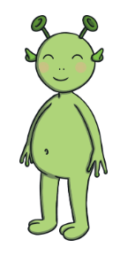

Read this  
nonsense word:

dus

Read this  
nonsense word:

zim

**+5 Points**

**+5 Points**

Read this  
challenge word:

jackpot

Read this  
challenge word:

rooftop



What sound is missing from this word?

c ns

What sound is missing from this word?

ips

**+8 Points**

**+8 Points**

Read this tricky word:

all

**+7 Points**

Read this tricky word:

was

**+7 Points**

**+6 Points**

**+6 Points**

Treat:

+ 10 points

Treat:

+ 10 points

Trick:

- 10 points

Trick:

- 10 points

Trick:

- 10 points

Trick:

- 10 points

Treat:

+ 10 points

Treat:

+ 10 points